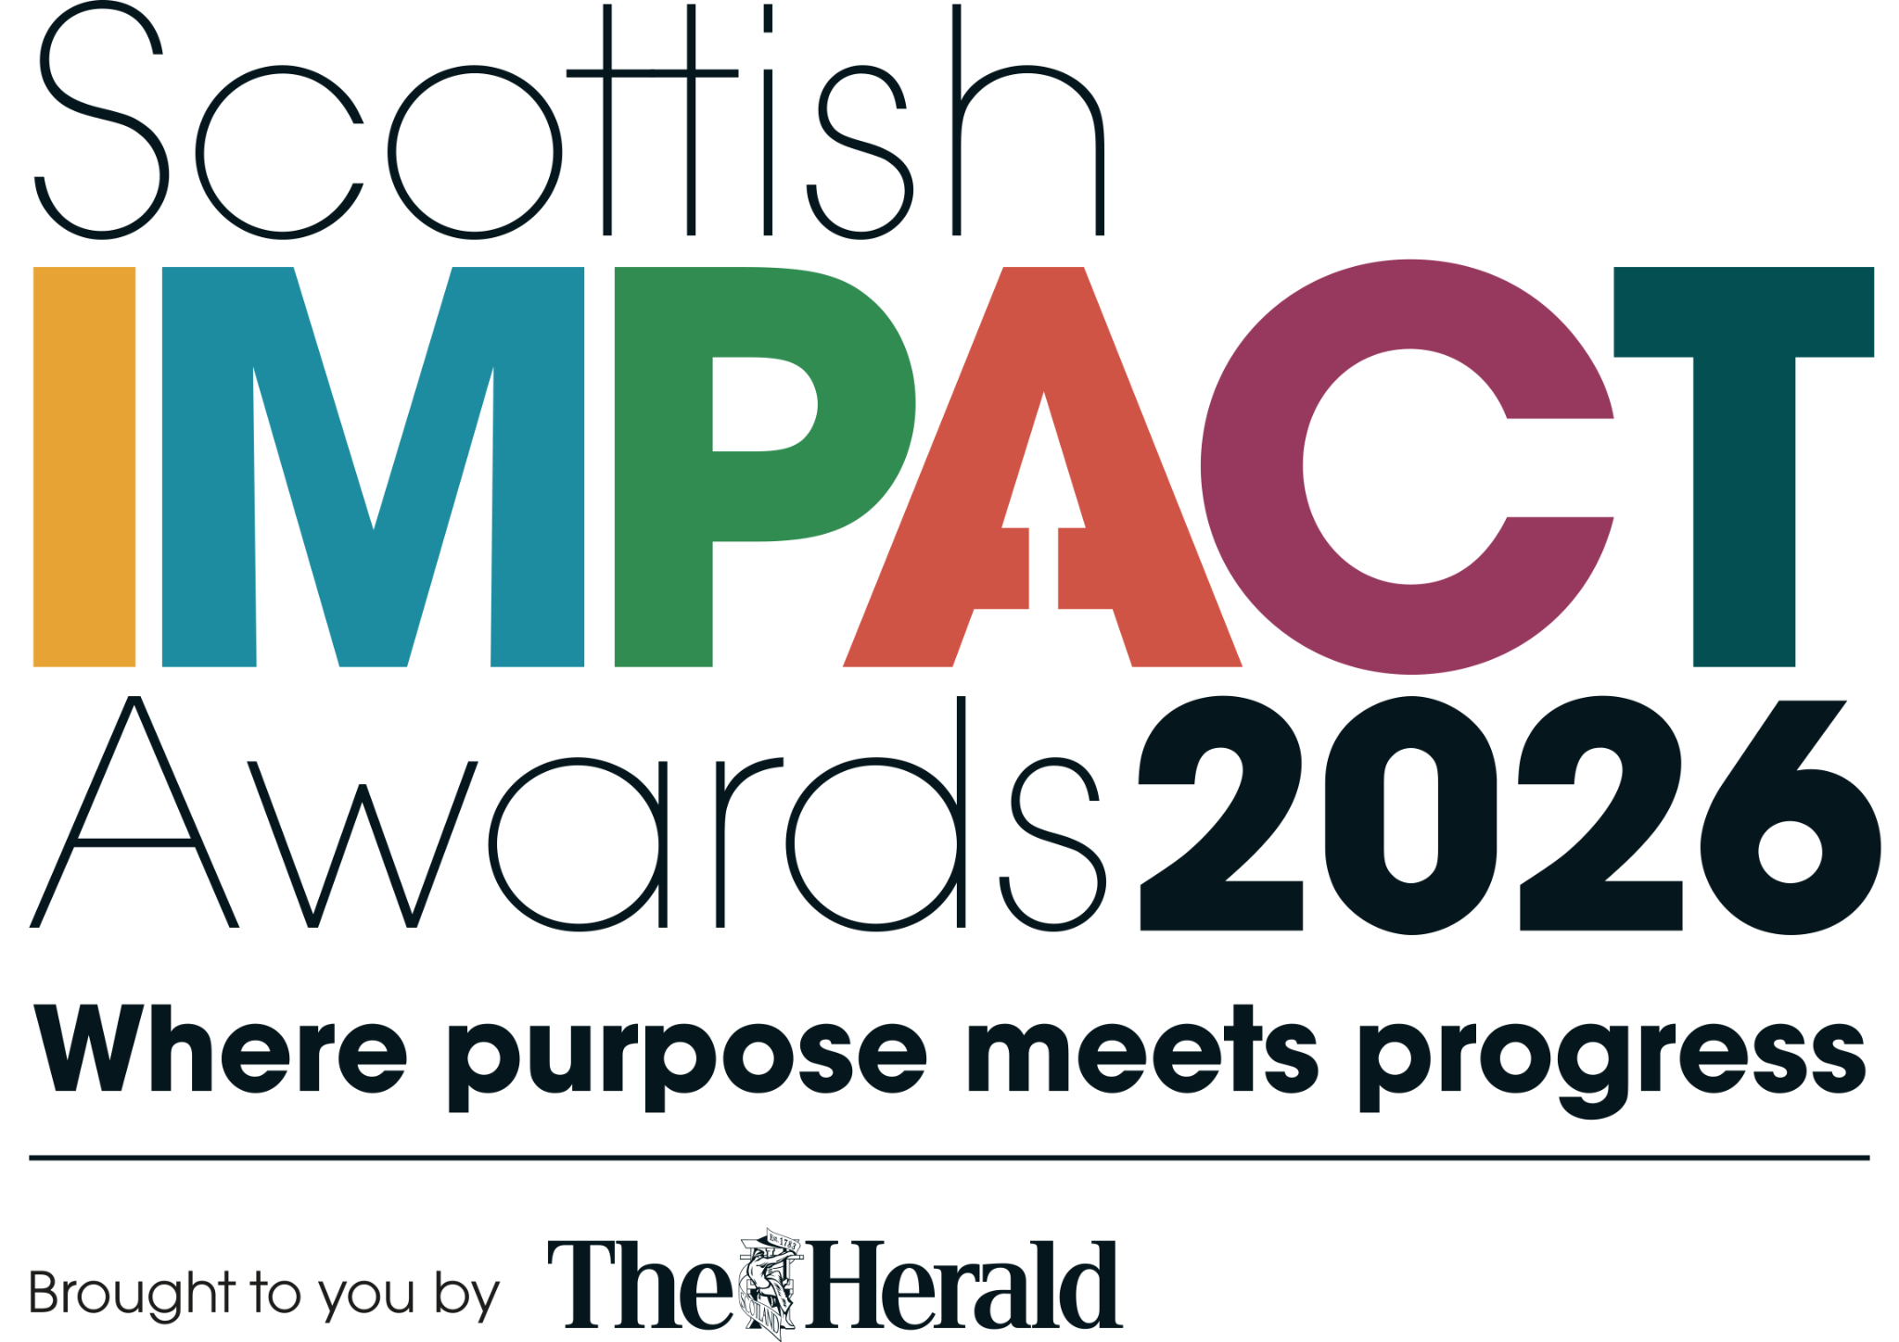
The Herald Scottish Impact Awards 2026
Wellbeing & Workforce Award Entry Form
The Scottish Impact Awards 2026 celebrate the organisations across Scotland that are leading the way in responsible business practices and embedding Environmental, Social & Governance (ESG) principles into their strategy, culture and community impact.
Entries are open to organisations of all sizes, from micro enterprises to large corporations, public sector, third sector and charities, and education, ensuring that outstanding efforts are recognised fairly and inclusively.
Key information
Entry fee | Free
Entries open | Monday, February 16, 2026
Entry deadline | Thursday, July 23, 2026, 6pm
Finalists announced | August 2026
Judging session | August 2026
Awards ceremony | Thursday, October 1, 2026, 6.30pm
Venue | Marriott, Argyll Street, Glasgow
Submission method | Submit via the online entry form; use this Word form to prepare offline.
Event contact | Sharon Franchetti, Event Manager | sharon.franchetti@newsquest.co.uk | 0141 302 6039

Important entry notes
Who can enter | • All registered organisations operating in Scotland, or organisations with a significant base in Scotland.  • Organisations of all sizes: Micro (1-10 employees), Small/Medium (11-250 employees), and Large (250+ employees).  • Applicants may enter multiple categories where relevant, provided each entry reflects a distinct area of impact.  • Each entry must demonstrate clear ESG initiatives and measurable outcomes specific to the chosen category.  • All categories are judged by organisation size to ensure fairness and inclusivity.
How to enter | Choose the relevant category or categories, prepare answers using this Word form, and submit via the official online entry form.
Online entry page | https://newsquestscotlandevents.com/events/scottish-impact-awards-entry/
Offline preparation | This Word document is editable and can be used to draft the entry before final submission.
Separate form note | This form is for one category only. Separate entries should be submitted for separate categories.
Shaded boxes are designed for entrant responses. Final submissions should be made online: Enter now
1. Eligibility confirmation
Please tick each statement before completing your entry.
☐ This organisation is registered and operating in Scotland, or has a significant base in Scotland.
☐ This entry demonstrates clear ESG initiatives and measurable outcomes specific to the chosen category.
☐ This entry relates to activity within the organisation, community, workforce, environmental impact or wider ESG practice.
☐ The entrant understands that entries are assessed relative to organisation size, sector and resources.
☐ The entrant is willing to provide supporting evidence or clarification if requested by the awards team or judges.
2. Entrant details
Organisation name* | Type here
Contact name* | Type here
Job title | Type here
Contact email address* | Type here
Contact phone number* | Type here
Organisation website* | Type here
Preferred social handle | Type here
Organisation address / Scottish base | Type here
Primary sector | Type here
Business size
☐ Micro (1-10 employees) | ☐ Small/Medium (11-250 employees) | ☐ Large (250+ employees)
3. Award category and entry profile
This separate form is for the category shown below.
☑ Wellbeing & Workforce Award
Entry / initiative title | Type here
Name of project, programme, service or organisation being entered | Type here
Location / Scottish footprint of entry | Type here
Time period covered by this entry | Example: January 2025 to June 2026
Where did you find out about the event?
☐ The Herald Article | ☐ The Herald Advert
☐ Email Communication | ☐ Social Media
☐ Word of Mouth | ☐ The Herald Newsletter
☐ Event Website | ☐ Other - please specify below
Other - please specify
Type response here...
4. Category overview and criteria
Award overview | The Wellbeing & Workforce Award recognises organisations operating in Scotland that prioritise employee wellbeing, mental health, fair and ethical employment, and positive workplace culture.
Entry criteria | The award celebrates organisations of all sizes that:  • Demonstrate ethical workplace leadership beyond compliance.  • Embed wellbeing and fairness into everyday practice.  • Have clear policies and initiatives promoting employee wellbeing and mental health.  • Demonstrate positive impact on employee satisfaction and retention through ethical employment practices.  • Are assessed relative to organisational size, sector and resources.
Relevant KPIs / indicators | • Do you measure employee engagement or wellbeing?  • Describe any trends, improvements or learning in staff retention or turnover.  • Outline your approach to pay fairness, pay gaps or progression.  • Describe any wellbeing, mental health or flexible working support in place.
Estimated completion time | Approximately 30-45 minutes.
4. Written submission
Please answer the questions below. Judges are looking for clear action, real impact, learning and progress, and impact relative to your organisation size and resources.
1. The challenge or opportunity
What challenge, need or opportunity did your organisation set out to address? (maximum 300 words)
Guidance:
- What issue existed?
- Who was affected and why?
- Why was action needed?
Type response here...
2. What you did
Describe what you did in response to this challenge or opportunity. (maximum 300 words)
Guidance:
- Wellbeing or mental health initiatives.
- Employment practices, pay or benefits.
- Leadership or cultural changes.
- Inclusion or fairness initiatives.
Type response here...
3. The impact
What difference has this work made so far? (maximum 300 words)
Guidance:
- Employee satisfaction, engagement or morale.
- Retention, recruitment or absenteeism outcomes.
- Wellbeing, mental health or work-life balance improvements.
- Cultural or behavioural change.
- Outcomes achieved relative to organisational size.
Type response here...
4. Impact indicators
To support transparency, fairness and accountability in judging, the following Key Performance Indicators (KPIs) are included as suggested guidance. Respond to any indicators that are relevant to your organisation. These are supportive, not compulsory, and should be interpreted relative to organisation size, sector and resources.
Employee engagement or satisfaction: do you measure employee engagement or wellbeing?
☐ Yes | ☐ In progress | ☐ In planning
Retention or turnover - Please describe any trends, improvements or learning. (maximum 200 words)
Type response here...
Fair pay and progression - Please outline your approach to pay fairness, pay gaps or progression, where available. (maximum 200 words)
Type response here...
Wellbeing support - Please describe any wellbeing, mental health or flexible working support in place. (maximum 200 words)
Type response here...
Any other relevant workforce or wellbeing outcomes? - Please describe any other relevant outcomes. (maximum 200 words)
Type response here...
4. Conclusion
Why should this work be recognised in this award category at the Scottish Impact Awards? (maximum 200 words)
Why this deserves recognition
Type response here...
Supporting documents
You may include supporting evidence to strengthen your entry. This may be in the form of uploaded documents or photos, or a link to a hosted video. We recommend one concise supporting document, where possible.
Examples may include:
- Policy summaries or action plans.
- Employee testimonials or survey extracts.
- Case studies.
- Images with captions.
- Retention, engagement, wellbeing, pay fairness or progression data.
Please ensure supporting files are named using the format category_company, for example CommImp_Herald.
Supporting document supplied? | Yes / No
File name(s) | Type here
Hosted video or supporting link, if applicable | Type here
Confidential information included? | Yes / No - if yes, please clearly mark it

Company information and publicity
This information will be used in the event programme and presentation if you are successful as a finalist.
50-word organisation bio (please write in the third person)
Type response here...
Organisation logo supplied? | Yes / No
Photo supplied relevant to entered category? | Yes / No
Publicity permission | Yes / Yes, but please seek approval before publication / No, judging purposes only
Photography note acknowledged | A Newsquest photographer may attend the event. Contact sharon.franchetti@newsquest.co.uk if you do not wish to be included in published photographs.
Data consent and event communications
Would you like Newsquest Events Scotland & NI to email you updates and information on future events?
☐ Yes - tick to opt in
Would you like to receive information from event partners?
☐ Yes - tick to opt in
Full privacy information is available from Newsquest Scotland Events. Privacy policy
Declaration
Please confirm the following before submitting your entry.
☐ I confirm that I have permission to submit this entry on behalf of the organisation named.
☐ I confirm that the information, performance data, testimonials, images and supporting materials are accurate to the best of my knowledge.
☐ I confirm that any submitted materials have been provided with appropriate permission.
☐ I understand that confidential information should be clearly marked and may be used for judging purposes only.
☐ I understand that final submissions should be made through the official online entry form unless the awards team advises otherwise.
Name of person submitting entry | Type here
Job title | Type here
Organisation | Type here
Date submitted | Type here
Submission checklist
☐ Completed all required contact, category and business size fields. | ☐ Answered the challenge/opportunity, what you did, and impact questions.
☐ Responded to relevant impact indicators where available. | ☐ Explained why the work deserves recognition.
☐ Included supporting evidence, where available. | ☐ Supplied organisation bio, logo and relevant image for finalist materials.
☐ Confirmed permissions, publicity choices and data consent options.

