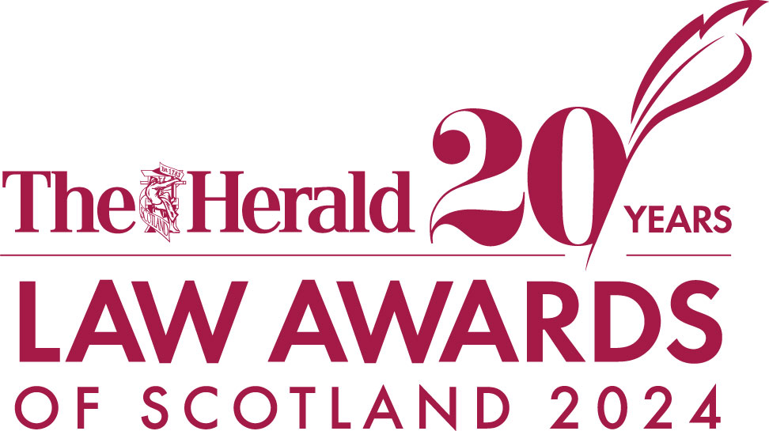

Entry Form

ENTRY RULES

1. The awards are free to enter.
2. Award sponsors or companies affiliated with award sponsors may not enter the category they sponsor.
3. You must have permission of the organisation or individual to nominate them to win an award.
4. Entries are treated in confidence.
5. The word count must be adhered to; judges are looking for clear and concise answers.
6. Supporting information can be included please ensure written material does not exceed two A4 pages.
7. You can submit multiple entries across the categories, but a separate submission must be made for each nomination.
8. Incomplete entries will not be judged.
9. All entries will be acknowledged on receipt. Entries will become the property of The Herald and entries will not be returned.
10. The Herald reserve the right to withdraw an award from any applicant supplying false information within their entry. Judges reserve the right to audit any information supplied.
11. The Herald reserve the right to withdraw an award or nomination from any applicant whose actions may bring the reputation of The Herald, its affiliated companies, the Judges, or our Sponsors in disrepute.
12. Judges reserve the right to move entrants within categories if they feel their criteria is better suited to another award, to remove categories or to update or add new categories during the awards process.
13. Information supplied will be shared with the judging panel and all information will be treated as confidential. It will not be used for any purpose other than judging the competition. Finalist organisations may be included in related media coverage and may be required to take part in promotional activities about The Herald Law Awards of Scotland 2024.
14. The judges’ decisions are final.
15. By registering and completing an entry for the awards you agree to these terms and conditions.
NOTES
You may use this entry form as a working document and then copy and paste into the awards entry site, or you can send the completed form directly to us.

Your entry should be saved as the category you are entering and your organisation name. For example: High Street Firm of the Year- The ABC Company.
You may submit multiple entries, and entries may be submitted in more than one category.

SUPPORTING MATERIALS
You are welcome to provide supporting material to enhance your entry such as photographs, video links, website links or testimonials. These should be uploaded along with your entry form or sent via email if entering directly.

To refer back to the category criteria please visit the event website: https://newsquestscotlandevents.com/events/lawawards-event/

Closing date for ALL applications is 6pm, Thursday, September 5.

Please note entries received after this date cannot be considered and will not be entered into the awards.

If sending direct please send your completed form to:
Sharon Franchetti
Event Manager
Sharon.franchetti@newsquest.co.uk
T: 07990 551 065

Organisation entry form

Section 1 - Contact information

Name of person submitting application:
Title:
Email:
Telephone:

Organisation details

Full name of organisation:
Email:
Telephone:
Company website (if applicable):

Category Entered:

Question 1
Referring to the entry criteria for your category, please tell us about your organisation and its achievements over the last year? (max. 600 words)

Question 2
Tell us why your organisation should win this award. You should again, refer to the entry requirements for the category you are entering (max. 1000 words)

Question 3
Please include a short description of the organisation/team. This will be used within the event programme should you/they be shortlisted. Please note this should be specific to your entered category. (max. 100 words)

REQUIRED
Please upload/email a photo relevant to the entry e.g. of the team AND a company logo. These will be used within the event programme and the awards presentation should you/they be shortlisted

Individual entry form

Section 1 - Contact information

Name of person submitting application:
Title:
Email:
Telephone:

Nominee details

Full name of individual:
Job Title:
Email:
Telephone:

Category Entered:

Question 1

Referring to the entry criteria for your category, please tell us about the individual and their achievements over the last year (max. 600 words)

Question 2

Tell us why this individual should win this award. You should refer to the entry requirements for the category they are put forward for (max. 1000 words)

Question 3
Please include a short description of the individual and their achievements. This will be used within the event programme should they be shortlisted. Please note this should be specific to your entered category. (max 100 words)

REQUIRED
Please upload/email a photo relevant to the entry e.g. a headshot of the individial AND a company logo. These will be used within the event programme and the awards presentation should you/they be shortlisted

