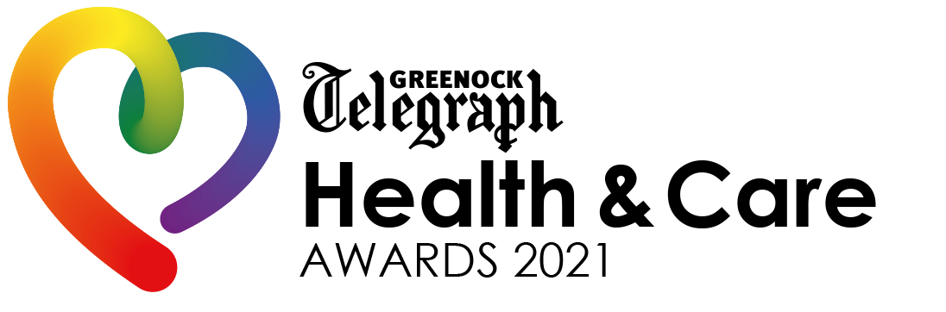
Greenock Telegraph Health & Care Awards 2021 Entry Form
ENTRY RULES

- The awards are free to enter.
- You may submit multiple entries across the different categories, but a separate submission must be made for each.
- The Greenock Telegraph reserves the right to withdraw any applicant found to be supplying false information within their submission from the process.
- The information provided within the entries will be treated as confidential. It will be shared with our judging panel but will not be used for any purpose other than judging the awards.
- The judging panel’s decisions are final and individual feedback cannot be given to entrants.
- The closing date for submissions is Wednesday, March 31

By proceeding to submit a nomination for the awards, you agree to the above terms and conditions.

SUPPORTING MATERIALS

We would love to receive supporting materials to help your nomination for example photographs, video links, website links or testimonials.

Your supporting materials should be emailed to Kirsty.loughlin@localiq.co.uk once you have submitted your entry. Please ensure written material does not exceed one page and that you send a maximum of five images.
SECTION ONE – Your information
Your Name:
Telephone Number:
Email Address:

SECTION TWO – Who are you nominating?
Name of nominated group/individual/business:
Contact Name at group/business (if applicable):
Their Telephone Number:
Their Email Address:

Chosen Award Category:

SECTION THREE – Tell us about your nominee…

To make a nomination for the Greenock Telegraph Health & Care Awards 2021, please answer the following questions. If you are unsure what to include, please review the chosen category criteria and let us know how your nominee meets the criteria.

- Why are you nominating this individual/group/business? Please give examples of what they have done that is extraordinary. (Max. 150 words)
- What did this group/individual/business set out to do and what results have been achieved? Give as much detail as possible. (Max. 150 words)
- Has their work inspired or benefited others in the community? We would like to hear how their efforts have influenced other people, in a small or major way. (Max. 150 words)
- Is there anything else you would like to add? Please list any additional information that supports your nomination here. (Max. 250 words)

Entry deadline: 6pm on Wednesday, March 31

Once completed, please email your form to Kirsty.Loughlin@localiq.co.uk

