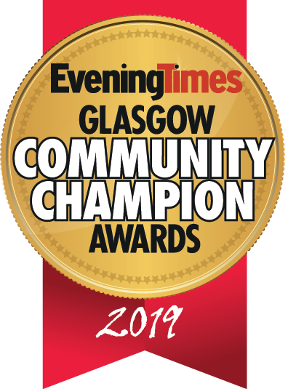
The Evening Times Glasgow Community Champion Awards in association with The Glasgow Fort.
2019 Entry Form
How To Enter

Please complete the following sections. All information supplied will be treated in the strictest confidence and used only by the judges for the purpose of selecting the winners.
The entry deadline is Tuesday, September 17, 2019
Entry Steps

•The awards are free to enter.
•The information provided within the entries will be treated as confidential.
•You may submit multiple entries across the different categories, but a separate submission must be made for each.
•The Evening Times reserve the right to withdraw an award from any applicant supplying false information within their entry. Judges reserve the right to audit any information supplied.
•Shortlisted organisations may be included in related media coverage.
•The judging panel’s decisions are final and individual feedback cannot be given to entrants.

Entry Form:
SECTION ONE – Contact Details of person submitting application

Name/title of person submitting application:
Phone Number:
Email Address:
Category Entered:

Entry Form:
SECTION TWO – About the organisation/project/individual being nominated

Name of Project:
Name of Individual or Team:
Job Title (where appropriate):
Organisation:
When was the work carried out:
Region active in: North East/ South/ North West
SECTION TWO – Submission Questions

Please describe a brief overview of the organisation/project/individual being nominated (Max 250 words):

What impact has this organisation/project/individual made on the local community (Max 500 words):

What makes the organisation/project/individual exceptional? Please give examples of what they have done (Max 500 words):

What did they set out to do and what results have been achieved? Please give as much detail as possible (Max 500 words):

Who has benefited from the project/initiative? Please give examples of how they have benefited (Max 250 words):

Has this work inspired others to get involved within the local community? (Max 250 words):

Please supply any additional information which may support your entry (Max 250 words):

Please provide a brief description of the nomination which will be included within the event programme should your entry be shortlisted (Max 100 words):

Please attach an image or logo to represent the nomination as part of the entry. This will be used within the event programme if your entry is shortlisted – This must be sent.

End of Form

Once you have submitted your nomination, it will be entered into our judging pack. A sifting session will take place to decide on a shortlist from each region. The public will then vote on https://www.eveningtimes.co.uk/ in order to decide the finalists across each category. A final judging session will take place to decide the award winners.
Please contact Stephen Downie at Stephen.downie@newsquest.co.uk on 0141 302 6014 with any questions.

