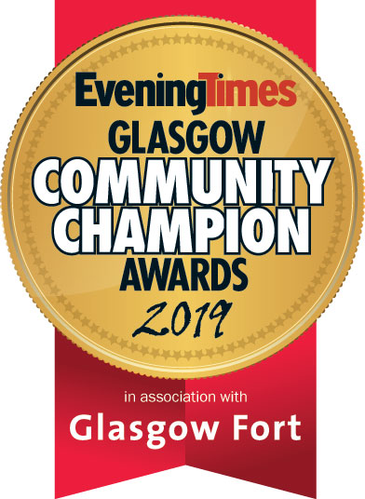
The Evening Times Glasgow Community Champion Awards
2019 Entry Form
How To Enter

Please complete the following sections. All information supplied will be treated in the strictest confidence and used only by the judges for the purpose of selecting the winners.
The entry deadline is Tuesday, September 17, 2019
Entry Steps

•The awards are free to enter.
•The information provided within the entries will be treated as confidential.
•You may submit multiple entries across the different categories, but a separate submission must be made for each.
•The Evening Times reserve the right to withdraw an award from any applicant supplying false information within their entry. Judges reserve the right to audit any information supplied.
•Shortlisted organisations may be included in related media coverage.
•The judging panel’s decisions are final and individual feedback cannot be given to entrants.

Entry Form:
SECTION ONE – Contact Details of person submitting application

Name/title of person submitting application: Joe Bloggs
Phone Number: 0141 555 5555
Email Address: Joe.bloggs@google.com
Category Entered: Health and wellbeing award

Entry Form:
SECTION TWO – About the organisation/project/individual being nominated

Name of Project: The Local Fitness Centre
Name of Individual or Team: Joe Bloggs
Job Title (where appropriate): Coordinator
Organisation: The Local Fitness Centre
When was the work carried out: 2018-2019
Region active in: North East
SECTION TWO – Submission Questions

Please describe a brief overview of the organisation/project/individual being nominated (Max 250 words):
The Local Fitness Centre is a grassroots community fitness centre located within Glasgow. Our twin aims are to build community and connection across the divides that exist in our area and to improve wellbeing through fitness and promoting healthy lifestyles in the local area.
The project started in 2000 as a result of people from the community centre saying that the area had no local fitness amenities. We also wanted to find an activity that would bring people together to help create “community” together. We decided that fitness, particularly classes, was a common language that can transcend any difference in people, from ability to economic background, cultural heritage to confidence levels. We hired a local fitness instructor as our first staff member, and we haven’t looked back!

Our main emphasis is on the health benefits of exercising and healthy eating. However, we also have a focus on upskilling unemployed people from the local area helping them gain employment.

What impact has this organisation/project/individual made on the local community (Max 500 words):

Since we began working in the local area, we have we have helped support people from different backgrounds, helping them come together to build a stronger community for themselves and others through making friends while helping them live a healthy lifestyle.

Through working with different partner organisations (such as Glasgow X, Y and Z), we have supported a wide range of people to become less isolated through engagement in fitness activities. Taking part in these groups contributes to improving people's physical and mental wellbeing, builds people's confidence and encourages participation in other community events.

In addition, we have also helped over 100 unemployed people gain employment through our innovative 8-week training programme designed to upskill people in all areas of business including catering, fitness, facility management and administration.

What makes the organisation/project/individual exceptional? Please give examples of what they have done (Max 500 words):

The Local Fitness Centre was established in 2000 to bring about a positive lasting change in the local area for the local community. We carry out exceptional services which benefit every from children to local businesses. The following people said that our fitness centre was:

Local Newsagents – “A local fitness centre for adults and young people who can come together, increase their fitness levels and increase their social circle. We have employed a weekend worker who completed their training programme.”

Local Citizen – “The Local Fitness Centre helps children from 6 to 12 have fun together during school holidays, allowing them to make fast progress in their chosen sports including football, hockey and running.”

What did they set out to do and what results have been achieved? Please give as much detail as possible (Max 500 words):

The aims and objectives of the fitness centre are to build community and connection across the local area and to improve the wellbeing through community fitness activities, sports and wellbeing classes. We believe we continue to do that every day by giving the chance to take part in a wide range of different sports and physical education. We also aim to help unemployed residents back into employment with skills training programme.

Having started in in 2000, we have grown from 4 staff members to 20. We have over 500 members of the fitness centre and have helped 100 unemployed residents back into employment through training. You can see from the quotations above and below that we are achieving what we want to.

Who has benefited from the project/initiative? Please give examples of how they have benefited (Max 250 words):

We have over 500 members who take part in fitness classes and attend the gym. This means we are benefitting a wide range of residents who are now living a healthier lifestyle, as well as their wellbeing. In a recent student, 94% of members said joining the fitness centre had allowed them to meet new friends while putting pride back into the community.

We have given 100 people work structure by helping them seek employment through upskilling them. Individually each member of our programme has faced huge challenges and by taking part in our programme they have been able to overcome these and find employment – further benefitting the local community.

We have also introduced a yearly charity football tournament with proceeds going back into the local community, allowing us to build a new play park at the local nursery.

Has this work inspired others to get involved within the local community? (Max 250 words):

We find that when people attend our classes, they see the benefit and want to bring along family and friends. An example of this is our running group which started with 5 members and has expanded to almost 45 members who run each Sunday morning through the park. We also have a family who attend showing the positive impact the fitness classes have.

We also get great feedback from the participants of other fitness classes including Zumba and body-pump who say taking part in the classes has changed their life and allowed them to take more pride in their community. This has led to them volunteering at a number of community led initiatives including the neighbourhood watch.

Please supply any additional information which may support your entry (Max 250 words):

-You could insert website.
-You could insert photographs.
-You could insert testimonials.

Please provide a brief description of the nomination which will be included within the event programme should your entry be shortlisted (Max 100 words):
The Local Fitness Centre is a local fitness centre in the North East of Glasgow which runs a wide range of physical education classes and fitness classes. We also run a skills training programme designed to help unemployed people back into employment.

Please attach an image or logo to represent the nomination as part of the entry. This will be used within the event programme if your entry is shortlisted – This must be sent.

End of Form

Once you have submitted your nomination, it will be entered into our judging pack. A sifting session will take place to decide on a shortlist from each region. The public will then vote on https://www.eveningtimes.co.uk/ in order to decide the finalists across each category. A final judging session will take place to decide the award winners.
Please contact Stephen Downie at Stephen.downie@newsquest.co.uk on 0141 302 6014 with any questions.

