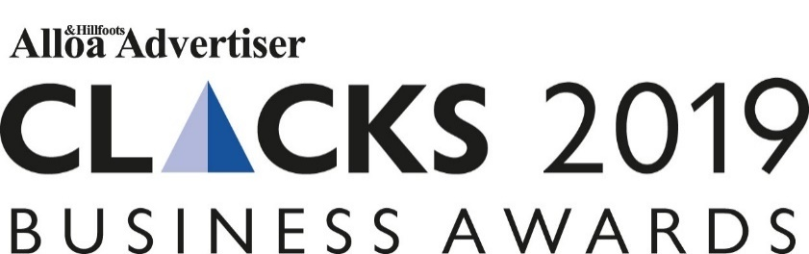

Clacks 2019 Business Awards Nomination Form

Nomination Process
Please browse through the award categories, read the criteria and submit your nomination for this year's Clacks 2019 Business Awards.

Make sure your contact details are correct, please do take time to consider your answers before submitting the online application. Provide as much information as possible to give you the best possible chance of winning! All information supplied will be treated in the strictest confidence and used only by the judges for the purpose of selecting the winner of each award category.

Step 1: Confirm you meet the eligibility criteria below:
•To be eligible, all entries must complete an online application.
• Anyone can nominate a company or individual or you can nominate your own business.
• All nominations entered into the awards must be affiliated to a business based in Clackmannanshire.
• Companies can be of any size, but must demonstrate success in terms of end results in relation to the criteria.
Step 2: Guidelines for completing your entry
• It is important that your entry is clear, concise and shows how you meet the category criteria as this is the basis on which you will be judged. The criteria can be found at the bottom of the entry form.
• You must include the name of the company, individual or company, including job titles, where appropriate.
• The Awards are FREE to enter and you may submit multiple entries in more than one category.
• Please note the judges’ decision is final and no correspondence will be entered into.
Step 3: Shortlist and Judging
- All nominations will be reviewed by the independent judging panel to create a shortlist.
- At this stage the judging panel will make their final decisions.

If you have any questions regarding submitting an entry please contact Nina Holmes on 0141 302 6036 or nina.holmes@newsquest.co.uk

Section 1: Choose your category

Category | Please put an X beside your chosen category
Business of the Year Award

Best Not-For-Profit Organisation Award

Community Spirit Award

Embracing Digital Technology Award

Excellence in Customer Service Award

Most Promising New Business Award

Success through Sustainability Award

Most Impressive Employee of the Year

Family Business of the Year

Apprenticeship Award

Section 2: Please complete the Company Details below

Full trading name of company or individual’s name:

Registered name if different from above:

Date established:

Address:

Company Telephone Number:

Company Website:

Name of the most senior person in the organisation:

Title:

Email:

Name of the person submitting application:

Title:

Email:

SECTION 3: Nomination Questions

This section should be used to tell us why you should win.

- In 100 words or less, provide a synopsis of your business or the individual.

- In 1,000 words or less, describe how you/they meet the category criteria. (You will find the category criteria at the bottom of this document for review)

- Additional Information – this can be pictures, testimonials or links to support your application.

- Max 75 words - Please give a brief overview of your business/the individual clearly summarising why you feel this business should be nominated. If you are shortlisted this could be used within an editorial feature and within the event script.

Please email your complete entry form to nina.holmes@newsquest.co.uk before 6pm on Wednesday, July 10, 2019. For support or for further information please contact Nina Holmes on 0141 302 6036.

Category Criteria

Please use the below criteria to help you shape and form your answers to the above question.

Business of the Year Award – sponsored by Ceteris
This award is to recognise a business that has had outstanding commercial growth within their industry sector. Judges will be looking for businesses that can demonstrate innovative projects, impressive results and a focus on employee engagement.
What the judges will be looking for
- What are the main activities of the business?
- What have you done to demonstrate impressive results?
- How do you stand out from the rest?

Most Promising New Business Award
It takes something special to make your mark in business. This award will go to a new Clackmannanshire business (Between 6 months and 3 years) that demonstrates an organic growth strategy and has achieved outstanding levels of sales, profit and market share improvement.
What the judges will be looking for
- What are the activities of the business?
- What have you achieved in the beginning of your business journey?
- What affect are you having within the Clackmannanshire area?

Best Not-For-Profit Organisation Award
From public sector agencies to third sector- charities, community groups, social enterprises and voluntary organisations, Clackmannanshire has them all. This award is to recognise the incredible achievements of our best not-for-profit organisations headquarted in Clackmannanshire.
What the judges will be looking for
- What are the main activities of the project/organisation?
- What results have been achieved?

Most Impressive Employee of the Year
We understand that most businesses wouldn’t be where they are without the strong workforce behind them. We want to hear about an employee that has gone above and beyond the call of duty over the last year. Let’s celebrate their hard work, achievements and outstanding contribution to their role and business.
What the judges will be looking for
- What are the main duties of the individual?
- What have they done to go above and beyond?
- How do they demonstrate that this is an outstanding member of staff?

Apprenticeship Award
This category is to celebrate Apprentices across all sectors, and recognising an individual who is set for a successful career in their chosen field. Whether your Apprenticeship programme specialised in engineering, healthcare or professional services, we want to highlight an individual who demonstrated significant improvement, a great work ethic and is an ambassador for Apprentices in the Clackmannanshire Area.
What the judges will be looking for
- What are the main duties of the individual?
- What have they done to demonstrate significant improvement?
- How do they stand out as an ambassador for apprentices?

Excellence in Customer Service Award
Customers are very important in all businesses and we want to recognise a business that has gone above expectations. If you offer excellent customer service within your business practice, then we want to hear from you today.
What the judges will be looking for
- What initiatives have you implemented to offer exceptional customer service?
- Do you go above and beyond for your customers?
- Do you demonstrate that customer service is at the heart of what you do?

Embracing Digital Technology Award
Digital platforms, communication and strategies are essential for every business. Are you a business who has implemented a digital element, such as an e-commerce system or a social platform, that has revolutionised the processes in your company? Have you embedded a digital system that has improved customer experience? Tell us about how digital has helped your business grow.
What the judges will be looking for
- What are the main digital activities of the business?
- Are you demonstrating a positive effect through the implementation of digital?
- Has your offering contributed to a better customer experience?

Community Spirit Award
This award recognises a business or company that put’s the community at the heart at what they do. From staff volunteering hours to CSR initiatives, has your company put giving back high on the agenda? We want to hear from businesses that have made a positive impact on the local community.
What the judges will be looking for
- What results have been achieved?
- Do you show that the community is at the heart of your business?
- What initiatives, projects, fundraising programmes have you implemented?

Success through Sustainability Award – sponsored by SV24-7 Vending
Responsible and remarkable. The winner of the award for sustainability will be a company that can show a consistent commitment to social and environmental improvements as part of its economic strategy. It will have systems in place to improve resource efficiency, have capacity and responsibility to contribute to socio-ecological improvements and engage with communities and other businesses to create a more sustainable economy. Does your company have a sustainable strategy that could be rewarded in 2019?
What the judges will be looking for
- What are the systems and procedures in place to deliver sustainability?
- What results have been achieved?
- What is your sustainability strategy?
- Have you engaged with other communities and businesses to create a more sustainable economy?

Family Business of the Year
This category is for a family business of any size, in any sector, which has enjoyed outstanding success. Are you a business steeped in family history or a new start-up enjoying a successful start to your family business career, then we what to hear from you!
What the judges will be looking for
- What are the main activities of the business?
- Do you demonstrate success in their chosen business sector?
- How has being a family business shaped your business plan?

